**Sql Project on HR Database**

1. **Creating three tables-**

**~ Employee**

**~ Benefits**

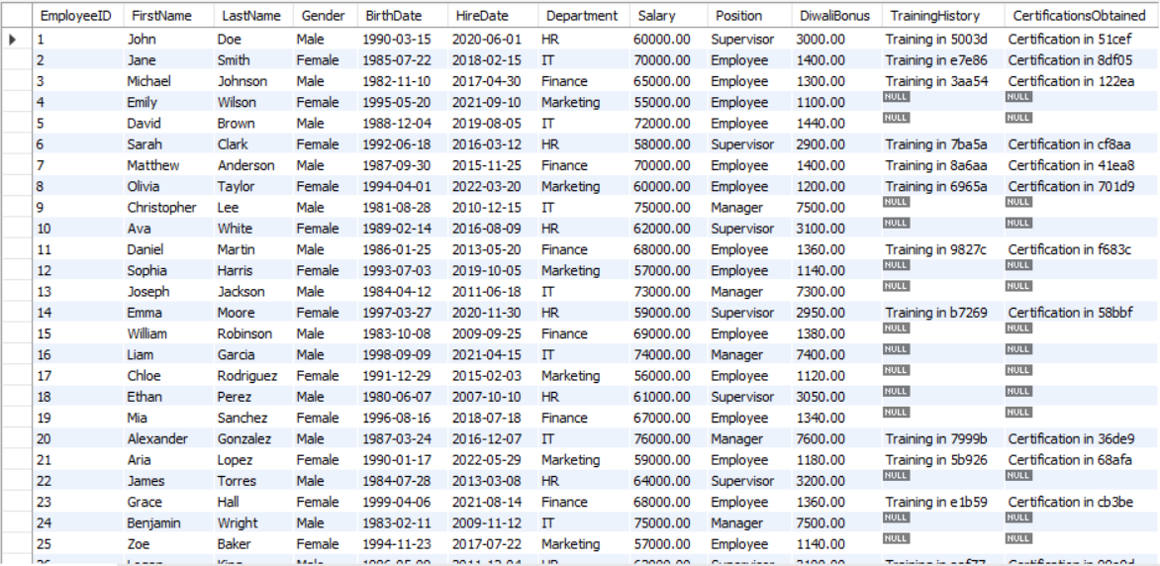**~ Timeoff**

**Fig. 1**

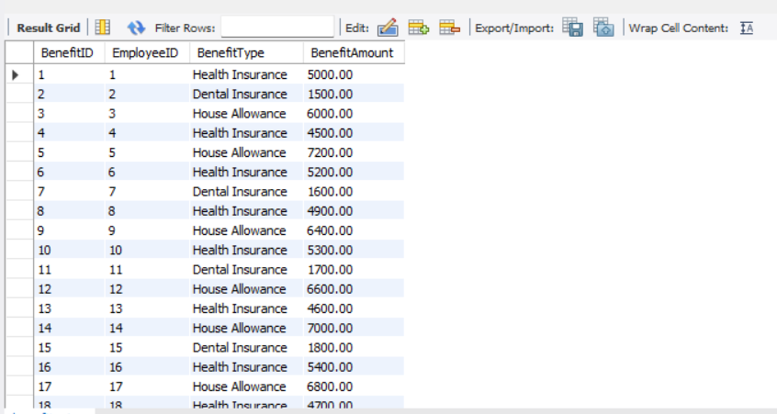

**Fig. 2**

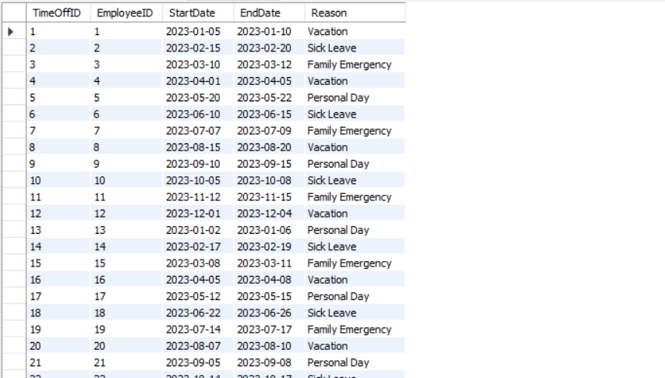

**Fig. 3**

**Queries**

1. 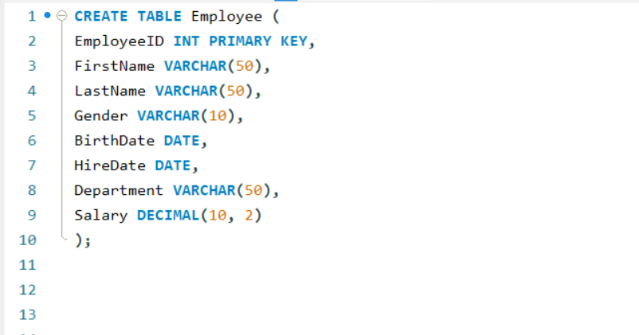**Creating Table Employee (Fig.1)**

* ***Note – The table was made upto “salary” later other columns were added***

1. 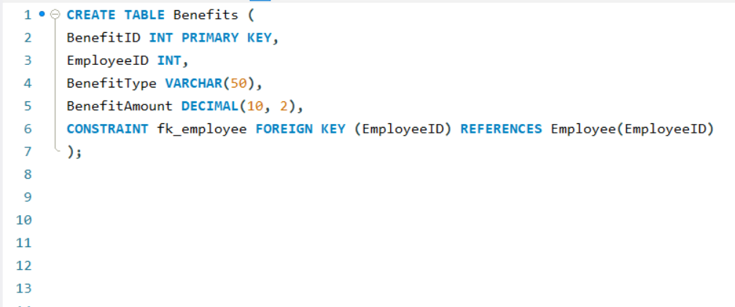**Creating Table Benefits (Fig.2)**
2. 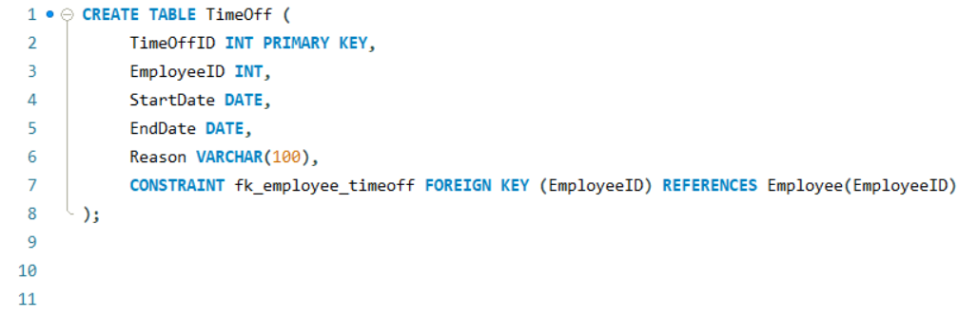**Creating Table TimeOff (Fig.3)**

1. **Inserting Data into Employee(Fig.1), Benefits(Fig.2),TimeOff(Fig.3)**

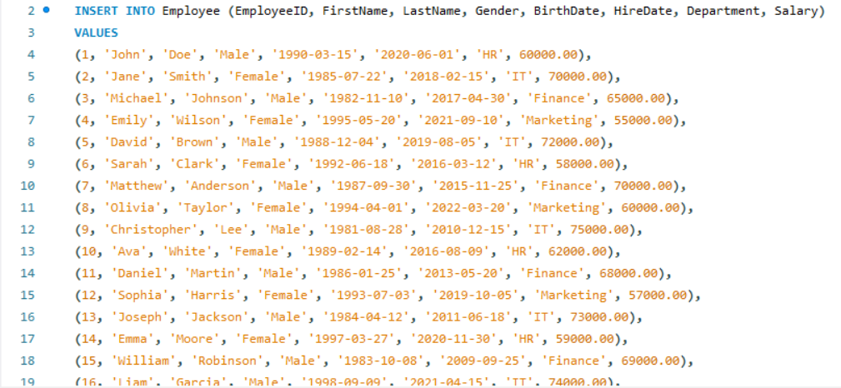

Main Queries

1. Employees who have taken no workdays in between for "Sick Leave" and have "Health Insurance" showing the total cost of health insurance

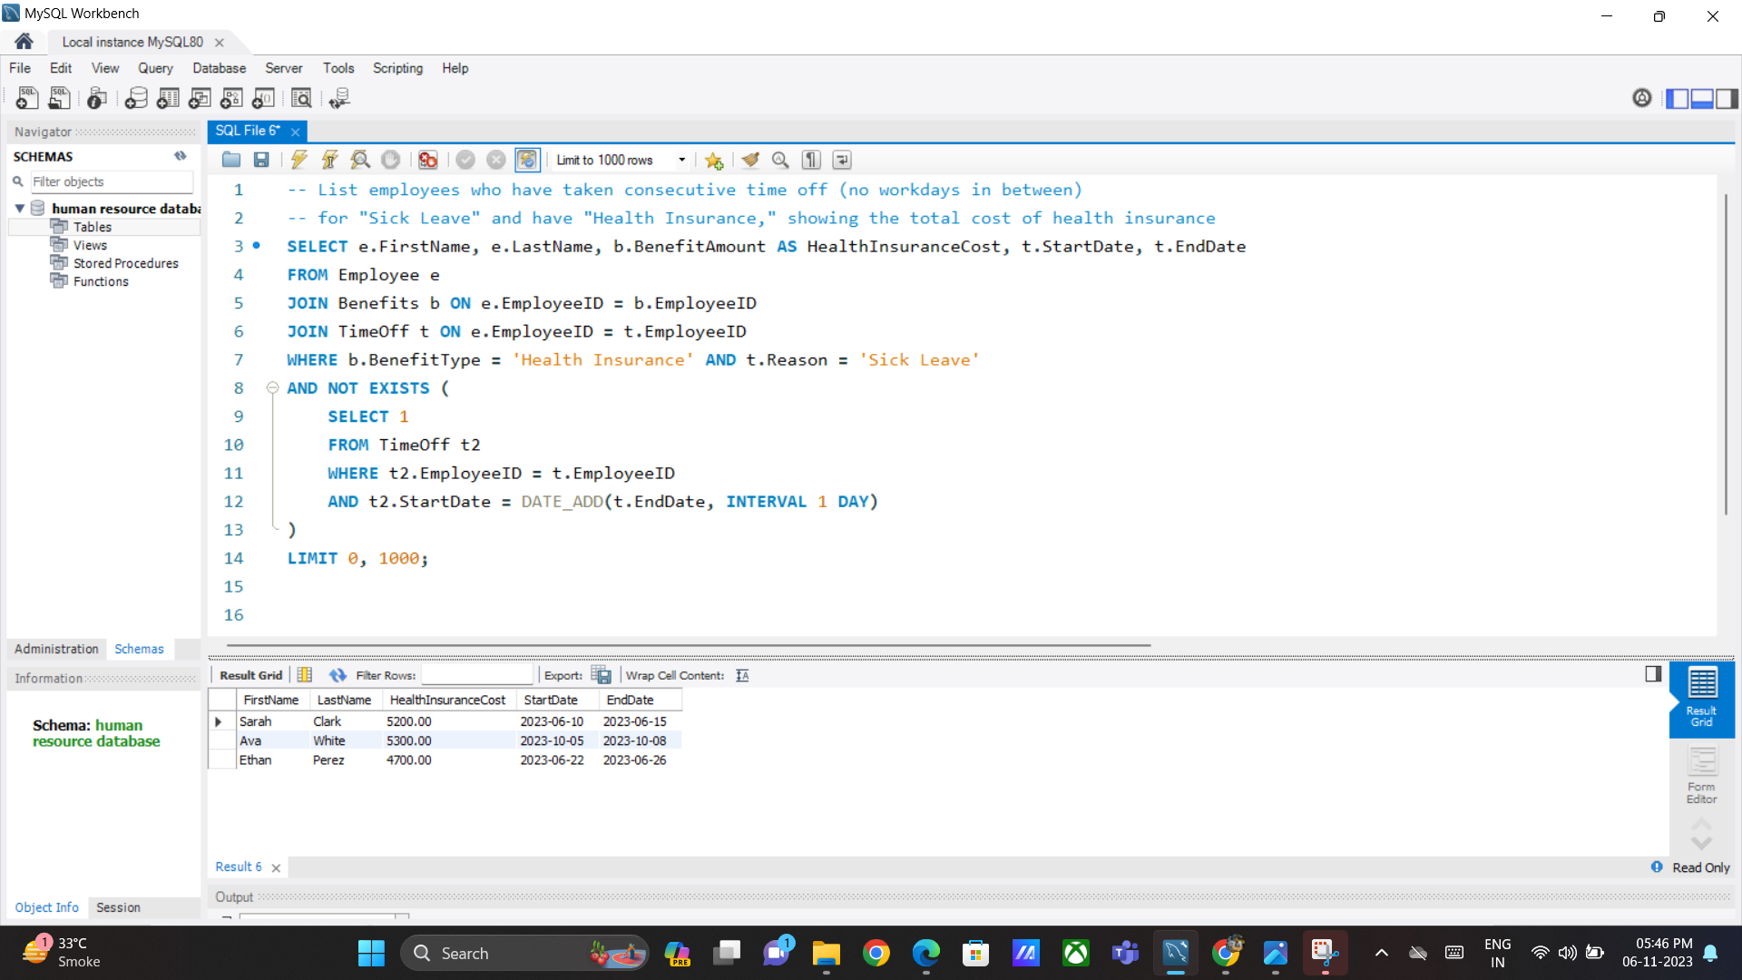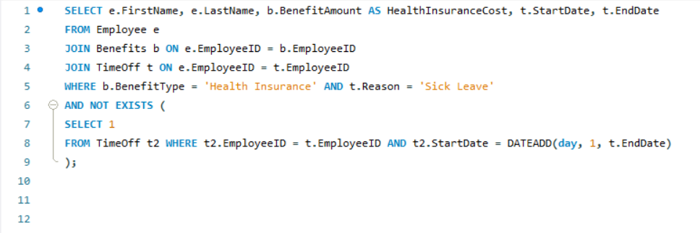

2.Calculating the total cost of benefits for employees who have taken "Vacation" in 2023 grouped by benefit type and showing only the benefit types with a total cost greater than 1,000

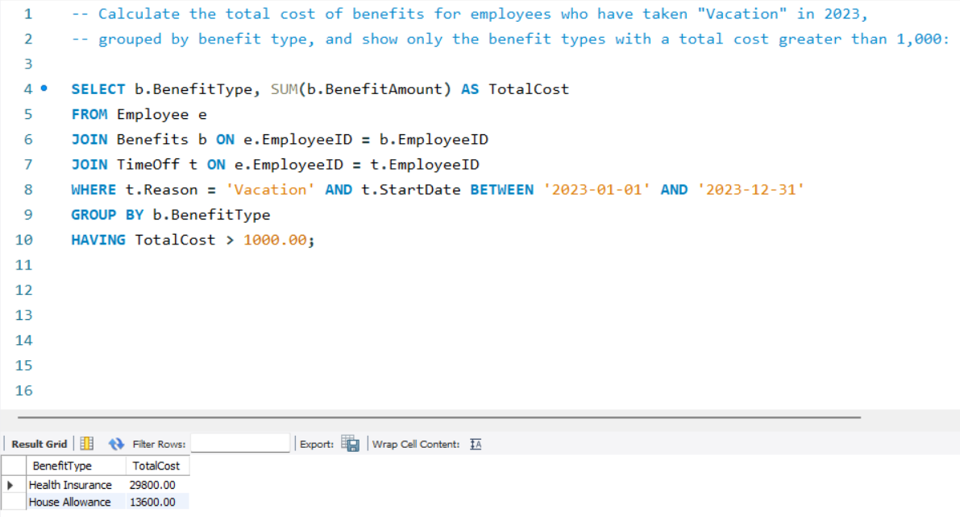

3. Employees who have taken consecutive time off for "Sick Leave" and have "Health Insurance"

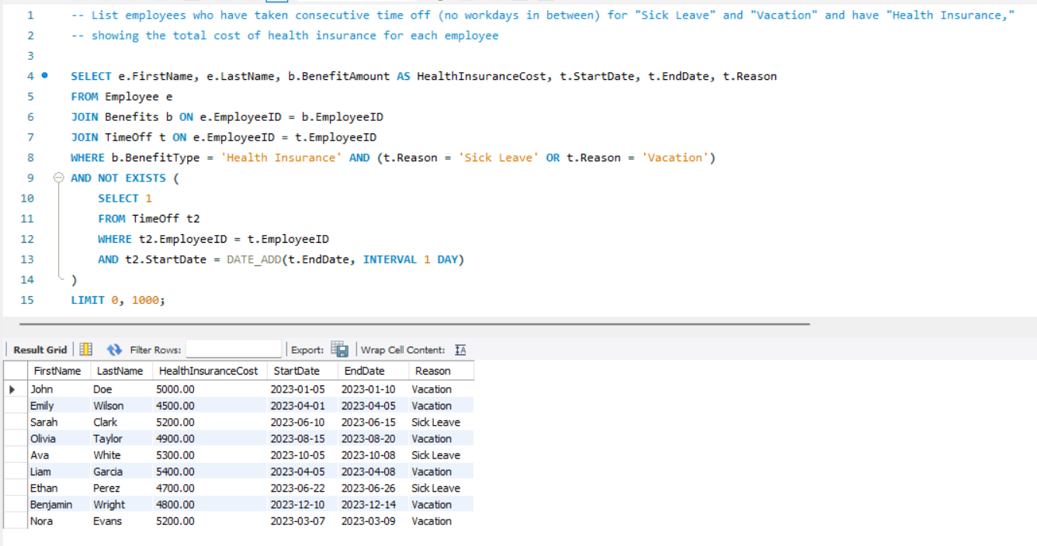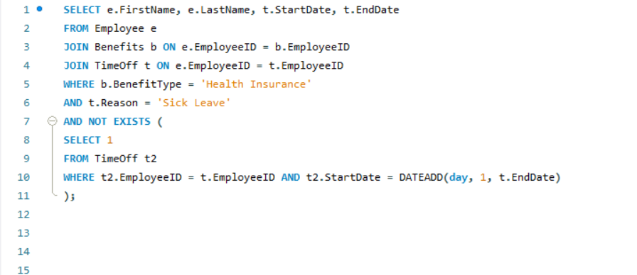

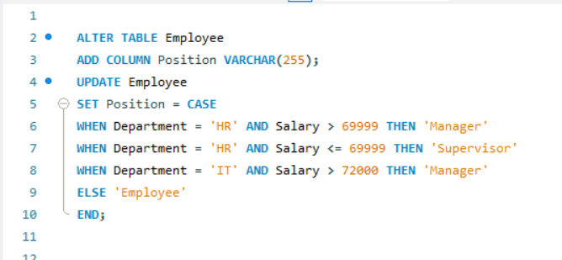4. Adding a new Column “Position” in the “Employee” Table based on conditions

**Output- Fig 1**

5. Adding new column “DiwaliBonus” in the “Employee” table based on conditions

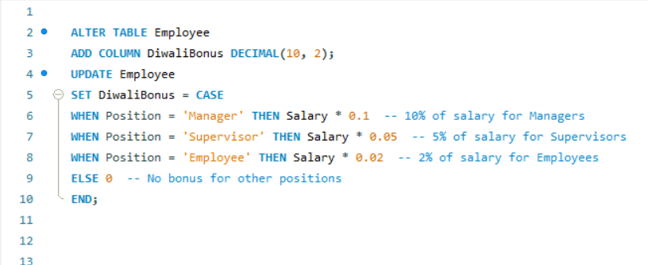 **Output Fig.1**

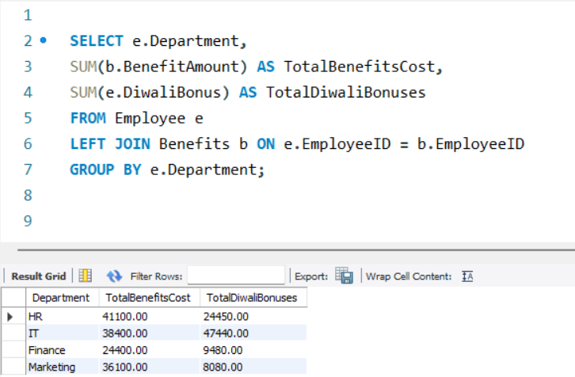6. Calculating the total cost of benefits and Diwali bonuses for each department

7. 2% Diwali bonus raise only for those in the 'Employee' position

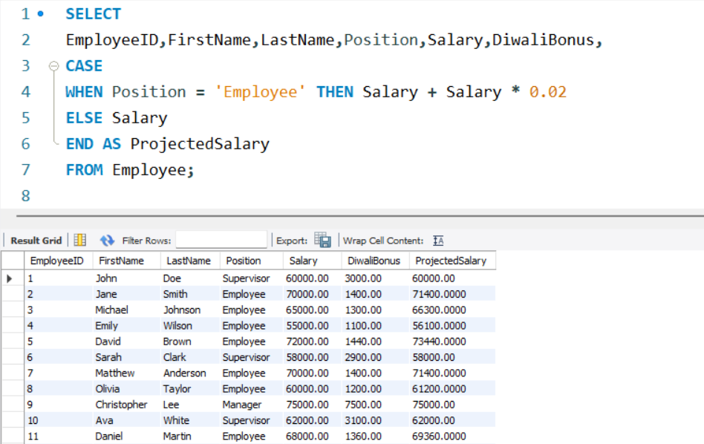

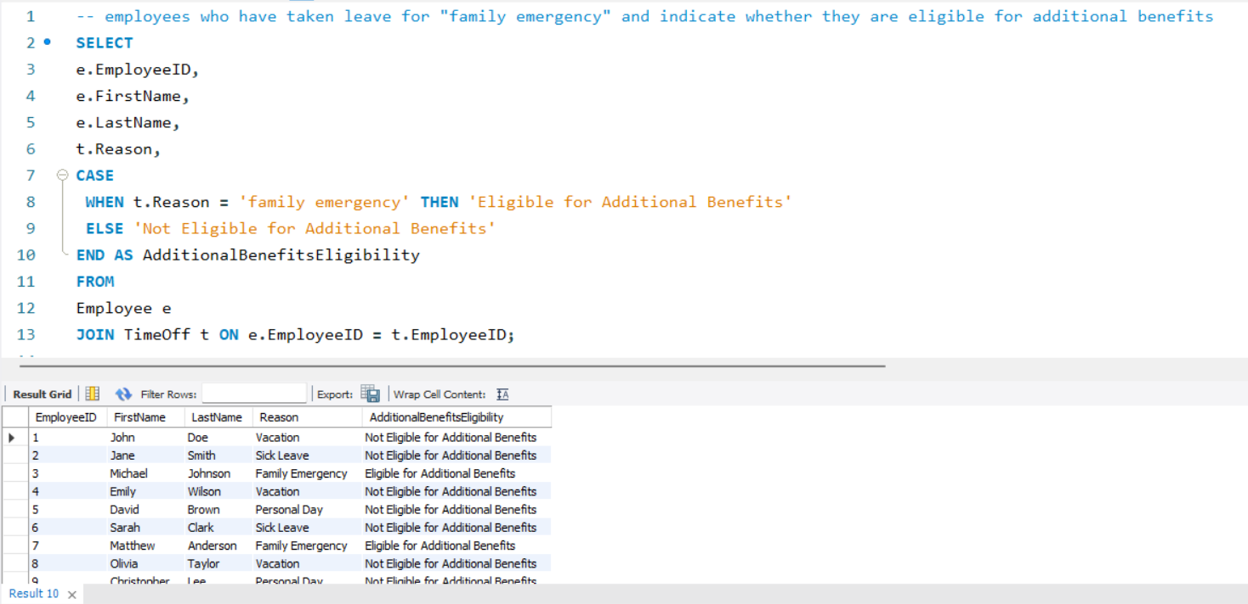8. Employees who have taken leave for "Family Emergency" and whether they are eligible for additional benefits

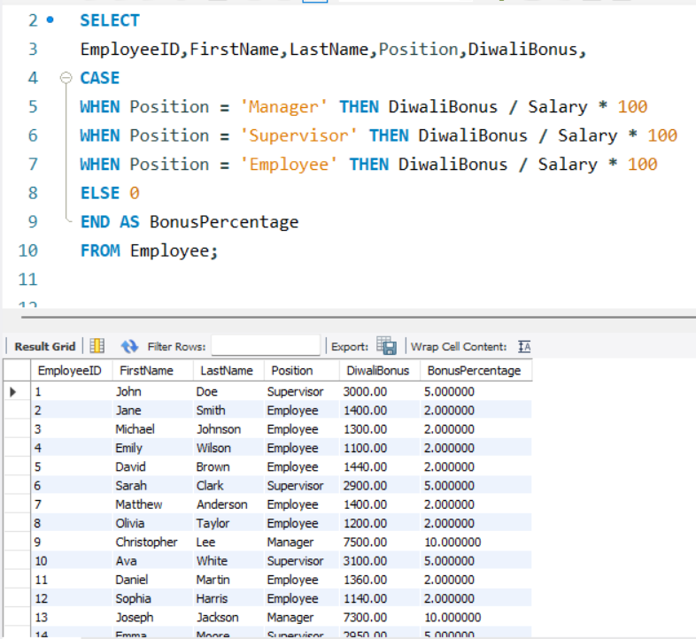9. Employees with their positions and the bonus percentage they received

10. Employees with their positions and indicate whether they received a Diwali bonus greater than a certain threshold

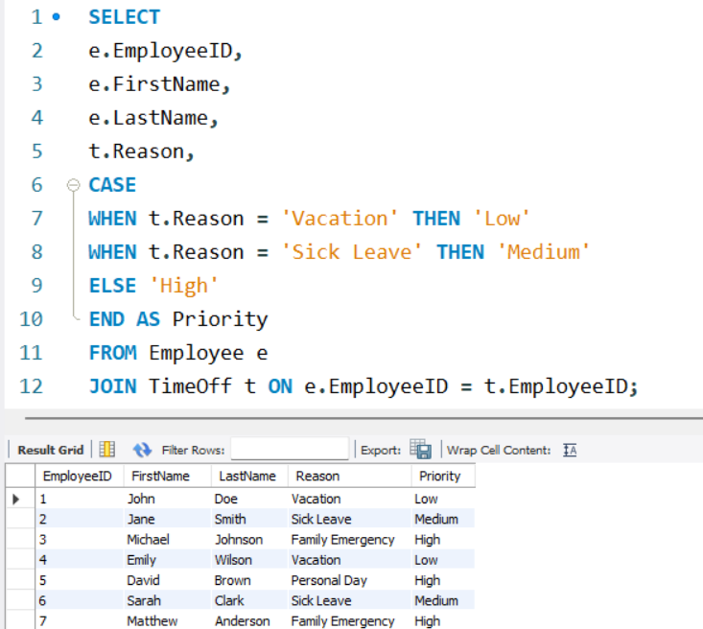11. Assign priority based on the reason for time off

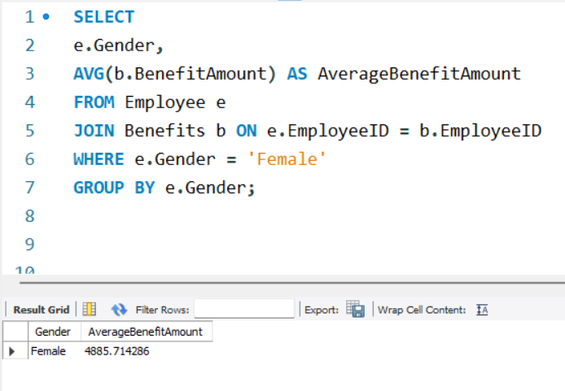12. Calculate the average benefit amount for female employees

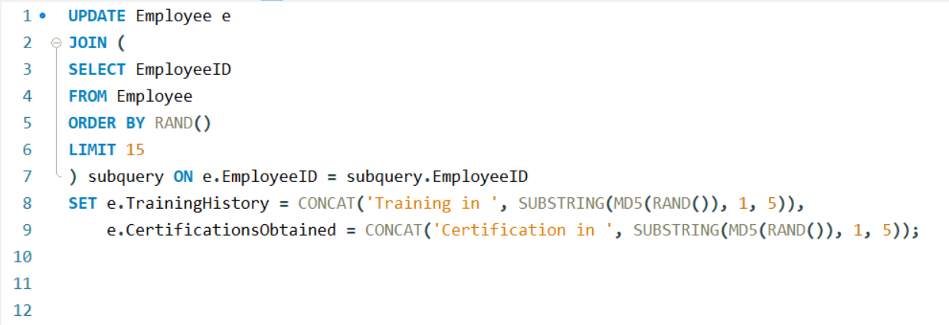13. Add a “TrainingHistory” column and a “CertificationsObtained” column to the Employee

**Output Fig.1**

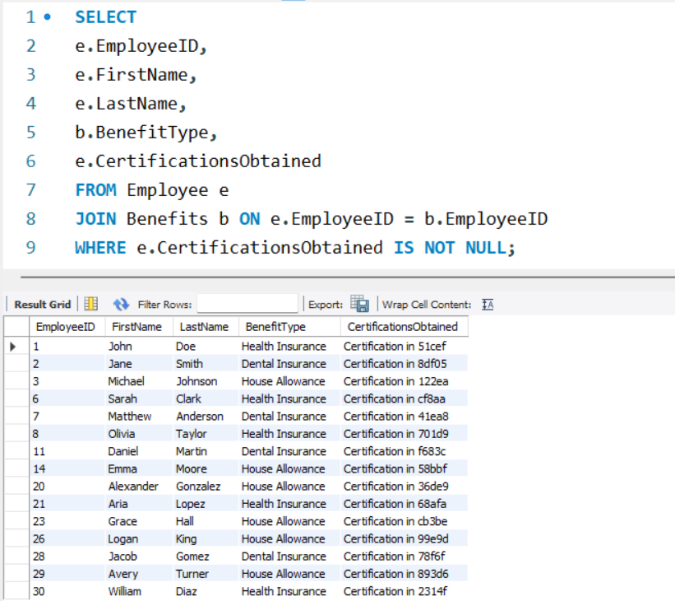14. Employees who have received benefits and have specific certifications obtained

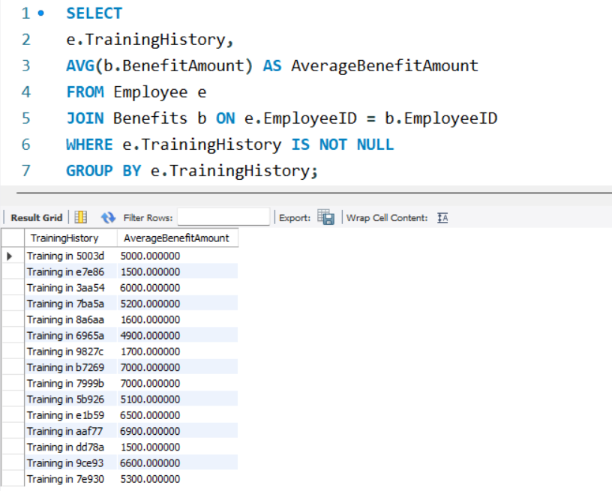15. Average benefit amount for employees with specific training history